**Aim:**

To create a Virtual Hard Disk (VHD) and allocate storage using VirtualBox.

**Procedure:**

**1. Open VirtualBox:**

* Launch the VirtualBox application on the host system.

**2.** **Create a New Virtual Machine:**

* Click **New** → Enter a VM name and select the operating system type/version.
* Proceed to the storage configuration section.

**3.** **Create Virtual Hard Disk:**

* In the “Hard disk” step, select **Create a virtual hard disk now**.
* Choose the disk file type (e.g., **VDI – VirtualBox Disk Image**).
* Select **Dynamically allocated** or **Fixed size** storage type.

**4. Allocate Storage Size:**

* Specify the size of the virtual disk (e.g., **15GB or 20GB**).
* Click **Create** to finish virtual hard disk creation.

**5.** **Attach Hard Disk to VM:**

* Go to VM **Settings → Storage**.
* Verify that the newly created hard disk is attached.
* Additional disks can also be added if needed.

**6.** **Verify in Virtual Machine:**

* Start the VM, boot the OS installer, and check the allocated disk during OS installation.
* Confirm disk space inside the installed operating system.

**OUTPUT:**

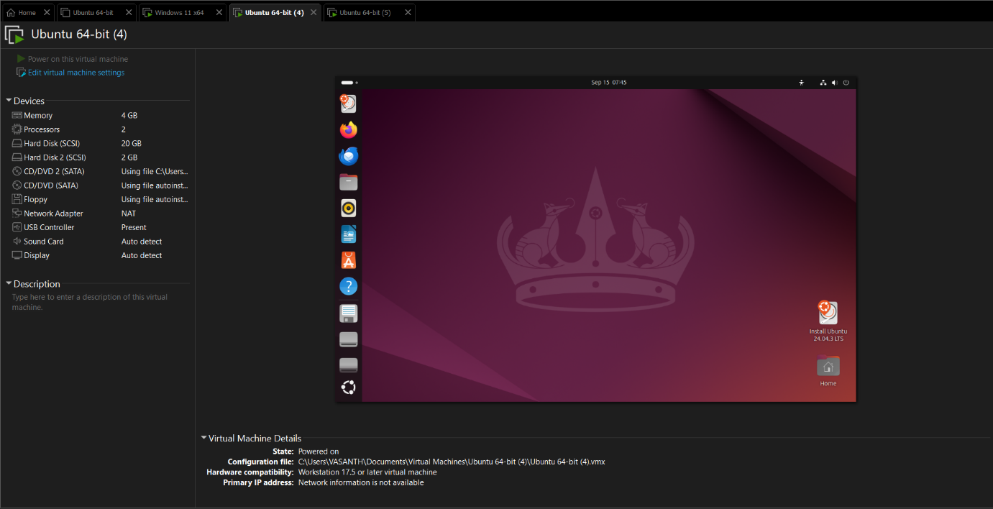

**Result:**

A Virtual Hard Disk was successfully created and allocated in VirtualBox, and the storage was verified during the OS installation process.